N = 3

1. NaCl

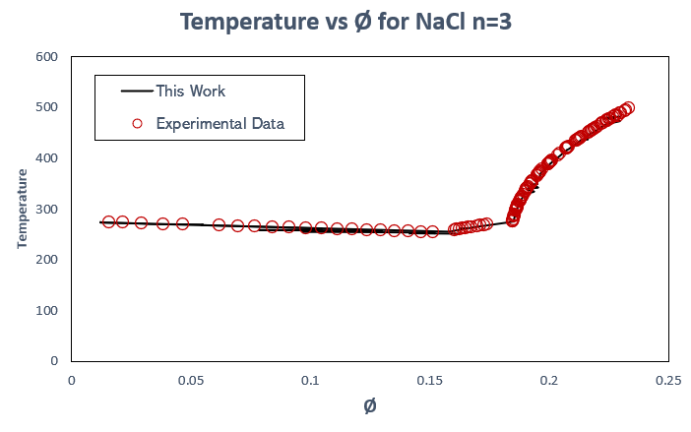

1. Li2SO4

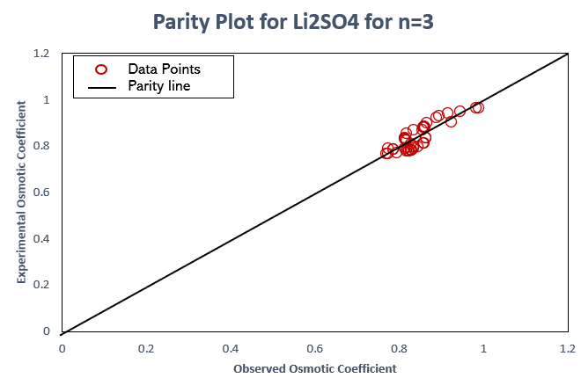

1. CaCl2

1. LiCl

1. MgSO4

